
Computer vision
Lab manual
Registration NUMBER: 2023-BS-AI-017 (6A) Submitted to: Ms. Esha Nawaz Submitted by:
Humna Imran
Department: Artificial intelligence

Table of content
Lab 1:Introduction to Computer Vision 3
Lab 2: Introduction to Deep Learning for Computer Vision 6
Lab 3 : Corner Detection and Fourier Transform 9
Lab 4 fourier transform: 15
Lab 5: Corner and Edge Detection via Eigenvalue Analysis 21
Lab 6: Image Thresholding 25
Lab 7: Unsupervised Image Segmentation 28
Lab 8: Felzenszwalb Graph-Based Segmentation 34
Lab 9: Image Segmentation Pipeline 36
Lab 10: CIFAR-10 Image Classification using CNN 40
Lab 11: Image Classification using Pre-trained CNN (MobileNetV2) 42
Lab 12: Simple Linear Regression with Scikit-Learn 48
Lab 13: Feature Extraction Using SIFT in OpenCV 50
Lab 14: HOG Feature Extraction for Image Analysis 52

LAB 1:Introduction to Computer Vision
Lab 1 introduces the basic concepts of Computer Vision and explains that images are simply grids of numerical values (NumPy arrays). Students learn how to load, display, and examine images using OpenCV and Matplotlib, along with basic operations such as converting images to grayscale and performing pixel-level modifications.The lab also explores two key challenges in computer vision: illumination changes and occlusion. Students observe how variations in lighting affect pixel values and how hidden or missing parts of an image make analysis more difficult.Next, students are introduced to a classical technique called Canny Edge Detection for detecting object boundaries. By applying it to images with different brightness levels, they learn that fixed thresholds do not perform well under varying conditions.The lab concludes with a mini-task where students apply all techniques to their own image and reflect on the results. Overall, the focus is on hands-on learning to build a clear understanding of the challenges in computer vision.
Viva related question:
- Why do edges disappear in dark images? Edge detection (like Canny) works by
calculating the intensity gradient (the difference in pixel values) between neighboring pixels. In dark images, the range of numerical values is compressed (e.g., all pixels are between 0 and 20). Because the "contrast" or mathematical difference between an object and its background becomes very small, the algorithm cannot find a threshold high enough to define an edge.
- Why is occlusion difficult? A computer "sees" an image as a static grid of numbers. If a black box covers an object, the original numbers are replaced by zeros. Unlike humans, who use "amodal completion" (our brain fills in the gaps based on experience), a classical machine vision algorithm sees the object as physically broken or as two completely different shapes.
- What information is lost in grayscale? Grayscale collapses three dimensions of data (Red, Green, and Blue) into a single intensity value. You lose chromaticity. For example, a red apple and a green leaf might have the exact same "brightness" or luminance value; in grayscale, they would look identical, making it impossible to distinguish them based on color alone.
LOAD LIBRARY:
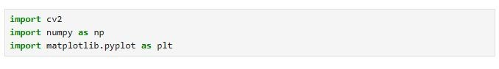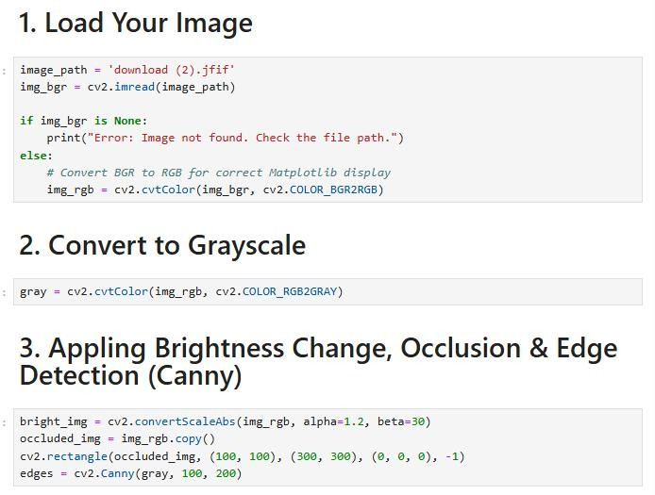
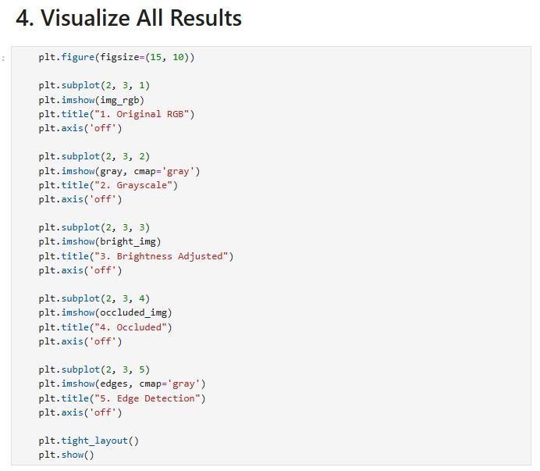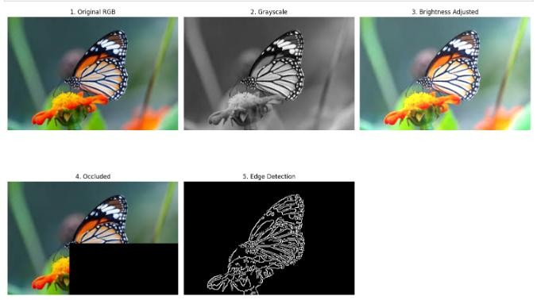

Lab 2: Introduction to Deep Learning for Computer Vision
Lab 2 introduces deep learning and shows how it improves upon classical computer vision methods. Building on Lab 1, where students learned that images are numerical arrays and that lighting and occlusion create challenges, this lab demonstrates how Convolutional Neural Networks (CNNs) can automatically learn features from data.
Students use PyTorch to load and preprocess images, convert them to grayscale, and organize them using ImageFolder and DataLoader. A simple CNN model is created with one convolutional layer and one fully connected layer to classify images into two categories.
The model is trained for a few epochs using cross-entropy loss and the Adam optimizer, and its performance is evaluated using accuracy on a test set.
This lab highlights that, unlike traditional methods, CNNs do not require manual feature extraction. Instead, they learn important patterns directly from data, helping to handle issues like lighting changes and occlusion.
Load library:
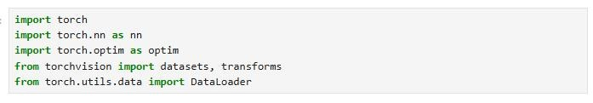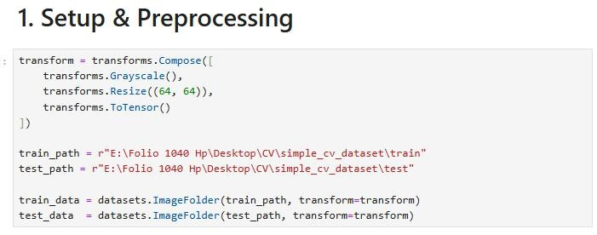
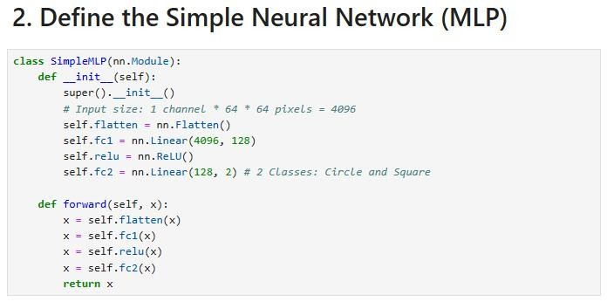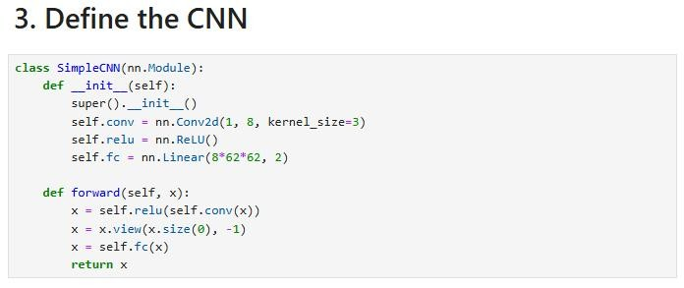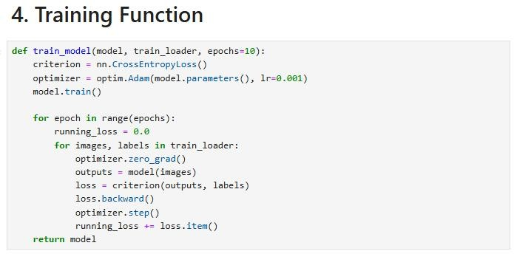
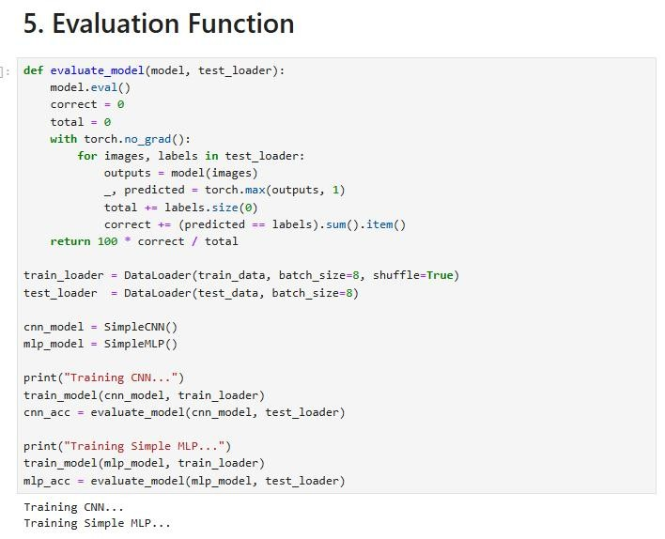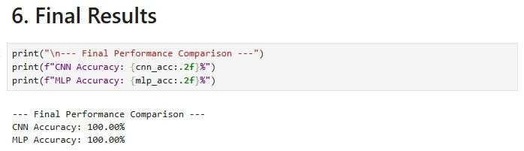

Lab 3 : Corner Detection and Fourier Transform
This combined lab introduces two important classical computer vision techniques: Harris Corner Detection and the Fourier Transform. These methods represent traditional approaches used before deep learning, focusing on understanding image structure in both spatial and frequency domains.In Lab 3, students apply the Harris Corner Detector to identify key points in an image where intensity changes sharply. The image is converted to grayscale and processed using OpenCV, and detected corners are highlighted. This method is useful in tasks like image matching, tracking, and 3D reconstruction.Lab 4 focuses on the Fourier Transform, where images are converted into the frequency domain using FFT. Students visualize the frequency spectrum and apply filters to understand image components. A low-pass filter is used to blur the image by keeping smooth regions, while a high-pass filter highlights edges and fine details.Overall, these labs demonstrate how traditional techniques analyze images using mathematical methods, forming the foundation for many modern computer vision applications.
TASK 1: Harris Corner Detection
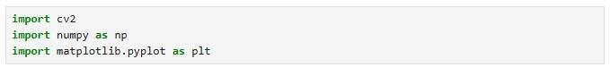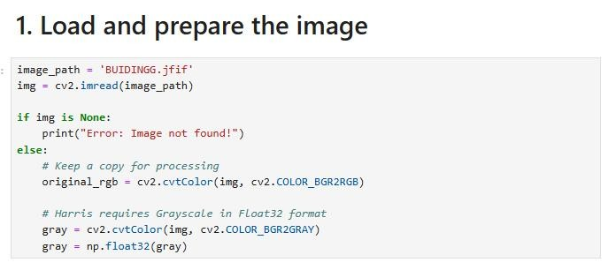
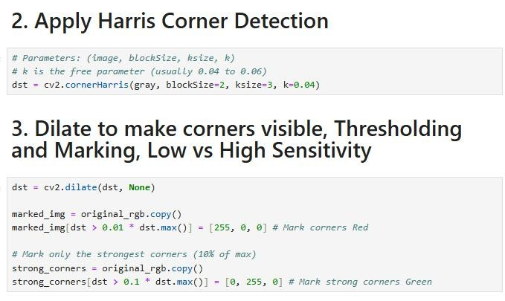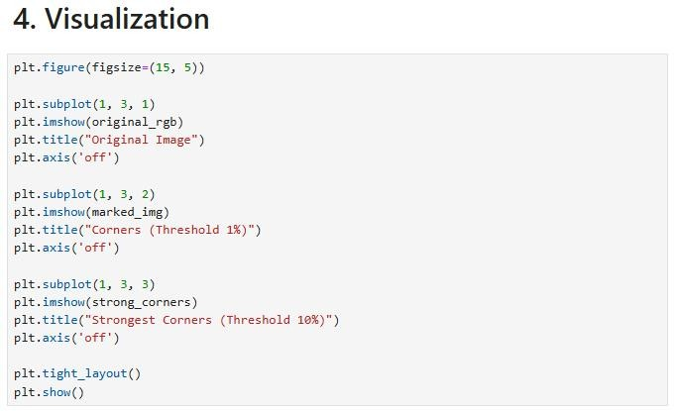
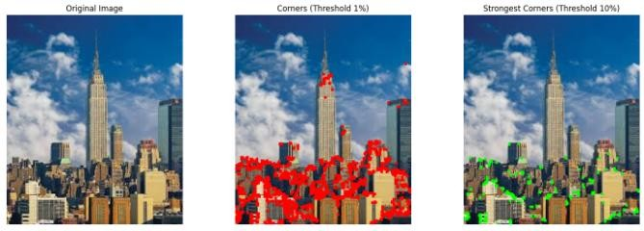
TASK 2: Image Processing in Transform
Domain (Fourier Transform)
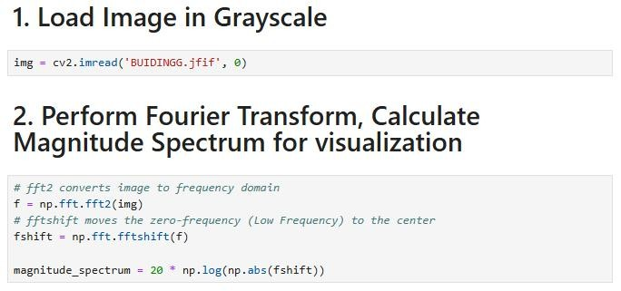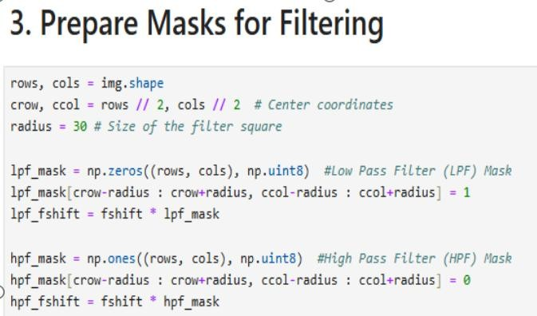
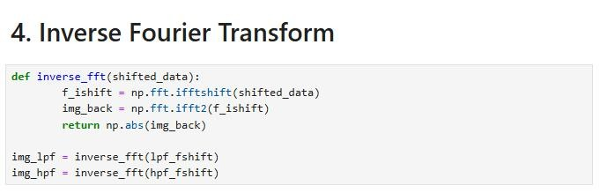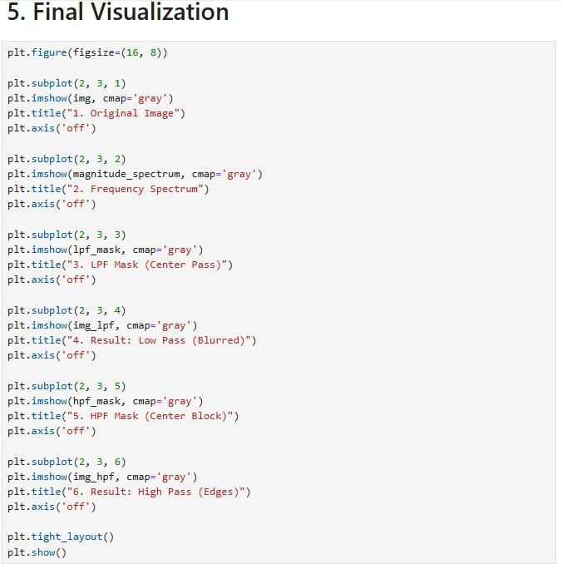

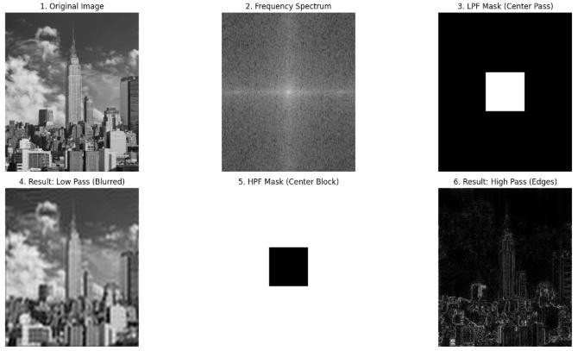
Lab 4 fourier transform:
Lab 4 focuses on the Fourier Transform, where images are converted into the frequency domain using FFT. Students visualize the frequency spectrum and apply filters to understand image components. A low-pass filter is used to blur the image by keeping smooth regions, while a highpass filter highlights edges and fine details.Overall, these labs demonstrate how traditional techniques analyze images using mathematical methods, forming the foundation for many modern computer vision applications.
Interactive Harris Classification (Harris Corner Detection)
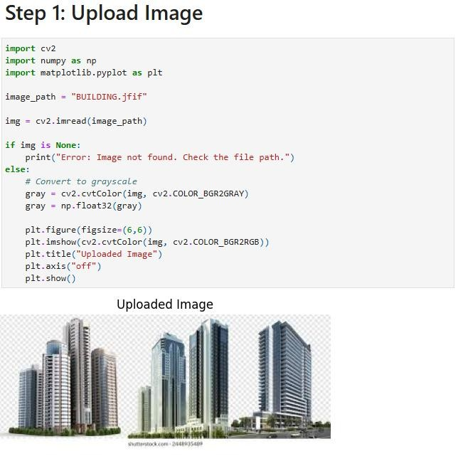
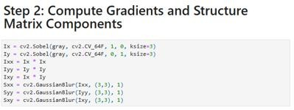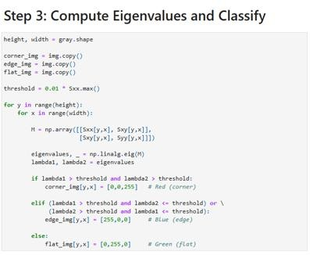
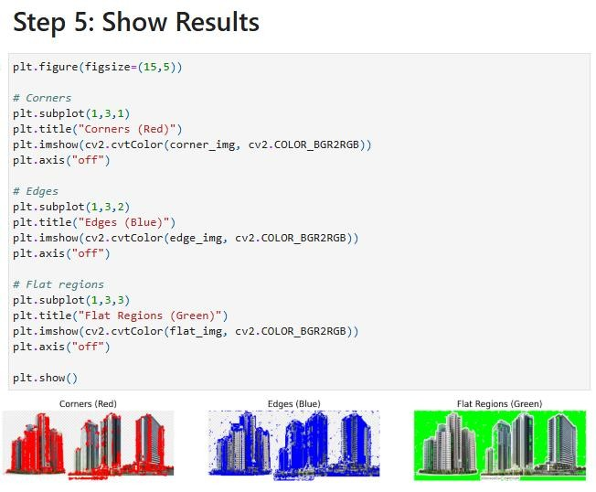
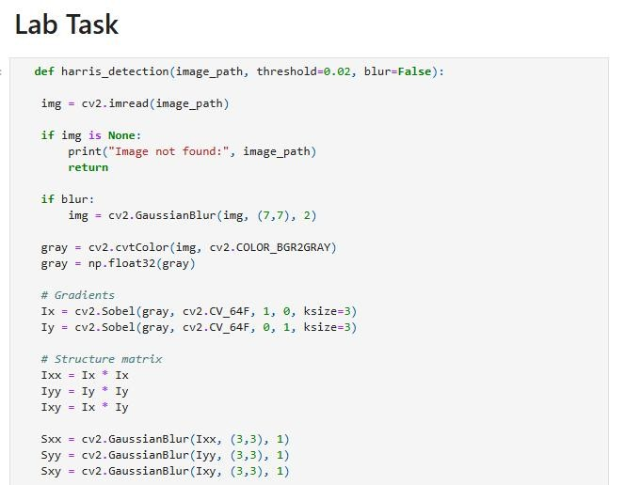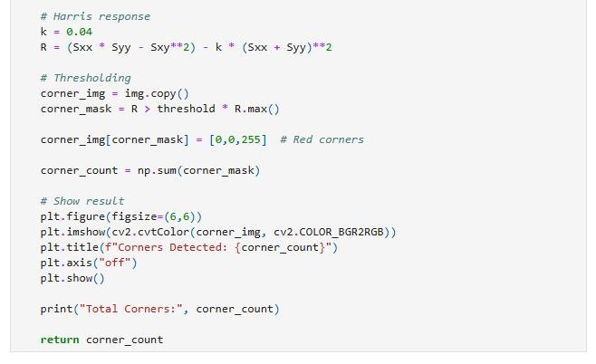
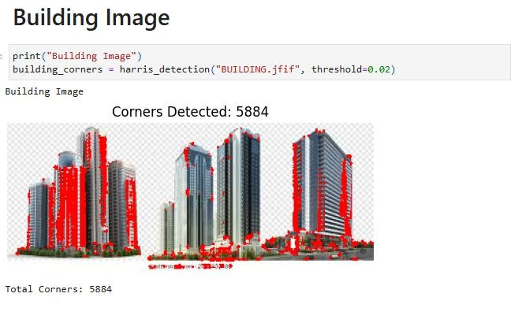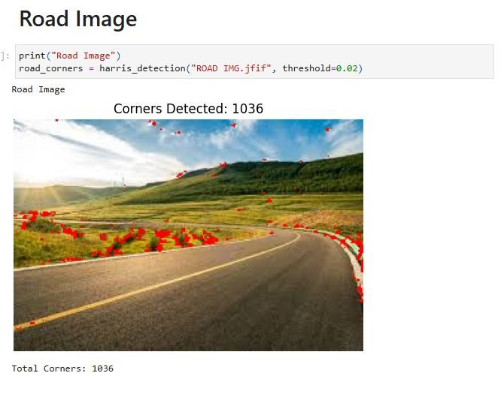
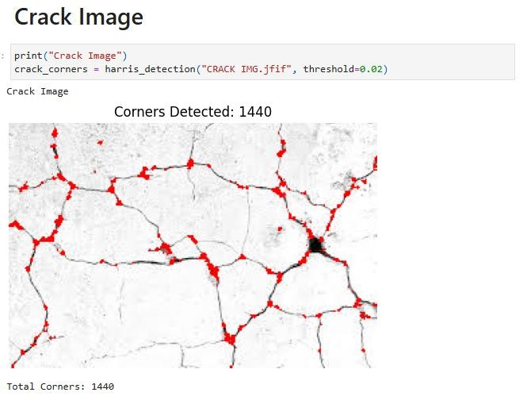

Lab 5: Corner and Edge Detection via Eigenvalue Analysis
Lab 5 focuses on implementing the Harris Corner Detection algorithm from scratch, helping students understand how it works mathematically rather than relying on built-in functions. The image is first converted to grayscale, and Sobel operators are used to compute gradients in both directions. These gradients are then used to form the structure tensor, which is smoothed using a Gaussian filter.For each pixel, eigenvalues of the structure matrix are calculated to classify regions. If both eigenvalues are large, the point is a corner; if one is large and the other small, it is an edge; and if both are small, it represents a flat region.The results are displayed using color coding: corners in red, edges in blue, and flat regions in green.This lab helps students understand that corner detection is based on mathematical concepts like gradients and eigenvalues, and allows them to experiment with thresholds to see how detection changes. It strengthens their understanding of earlier concepts and prepares them for advanced computer vision tasks.
Real-Time Object Detection with OpenCV and MobileNet SSD
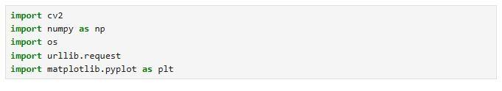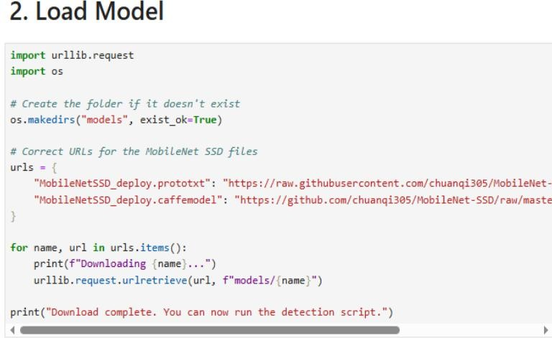
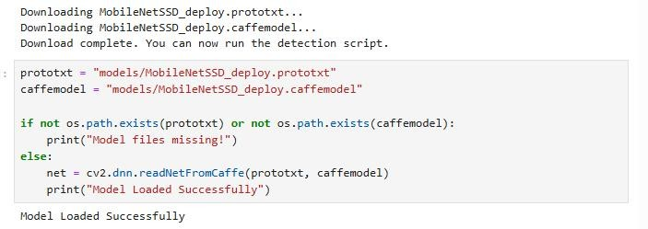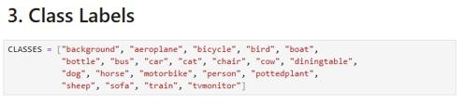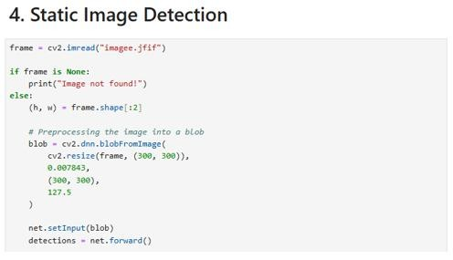
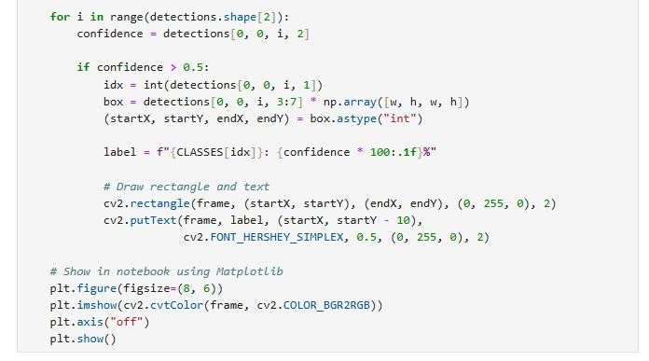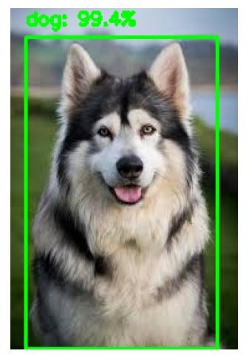
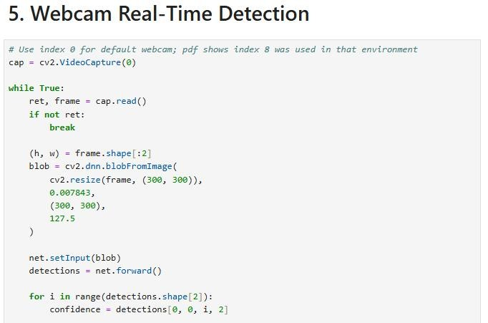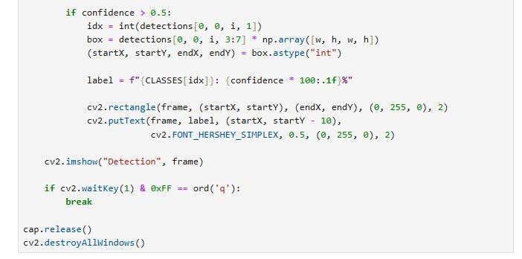

Lab 6: Image Thresholding
Lab 6 introduces image thresholding, a basic technique used for image segmentation. It shows how a grayscale image can be converted into a binary (black-and-white) image to separate objects from the background based on pixel intensity.Students load an image using OpenCV and convert it to grayscale. Then, a binary threshold is applied where pixels above a certain value (127) become white, and those below it become black. This highlights the main object while removing unnecessary details.The lab displays the original image, grayscale version, and final binary result for comparison, helping students clearly understand the effect of thresholding.Overall, this lab demonstrates a simple yet important preprocessing step and encourages students to think about how threshold values and lighting conditions affect results.
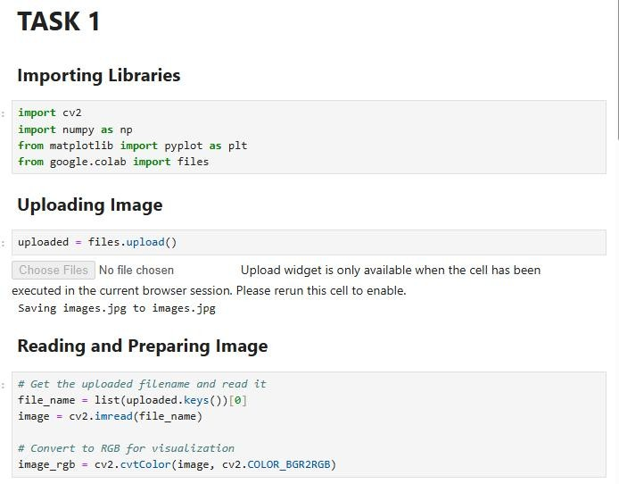
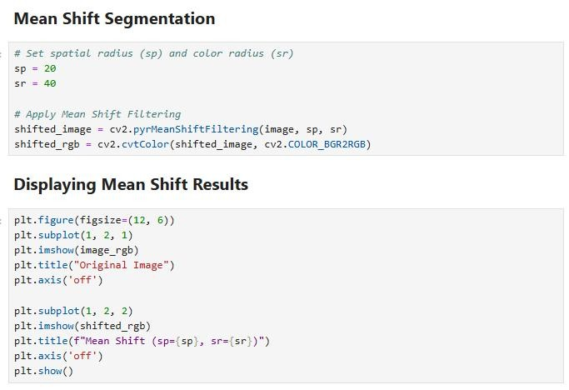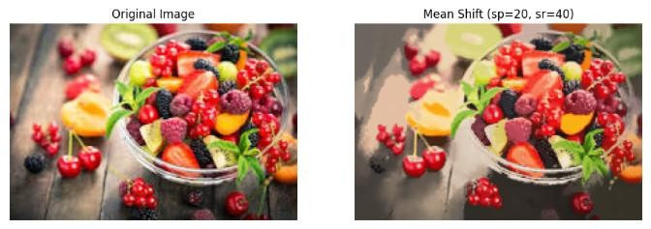
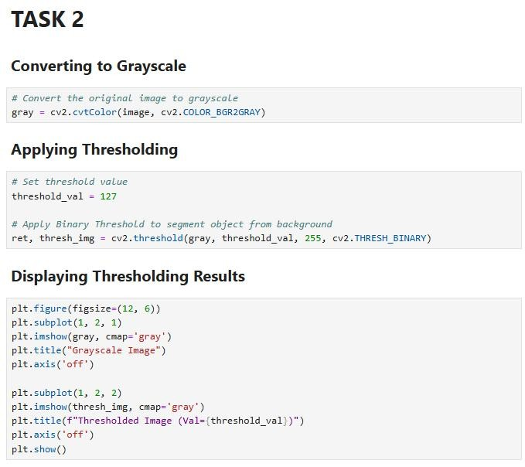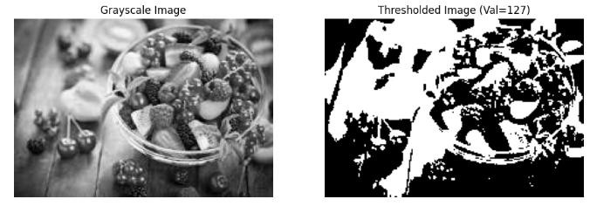

Lab 7: Unsupervised Image Segmentation
Lab 7 introduces an unsupervised image segmentation pipeline that divides an image into meaningful regions without using labeled data. It combines three main techniques: smoothing, superpixel segmentation, and region merging.First, the image is preprocessed using a bilateral filter to reduce noise while preserving edges. Then, the SLIC algorithm is applied to divide the image into small regions called superpixels. These superpixels group similar pixels together based on color and proximity.Next, a Region Adjacency Graph (RAG) is created, where neighboring regions are connected and compared based on color similarity. Similar regions are merged using a threshold, reducing many small segments into fewer meaningful regions.Finally, the results are displayed by comparing the original image, the segmented superpixels, and the final merged output.This lab helps students understand how images can be segmented using clustering and graph-based methods, forming a foundation for advanced image analysis tasks.
Task 1:
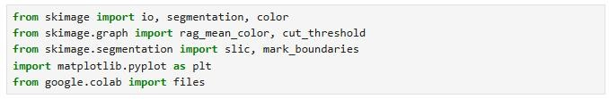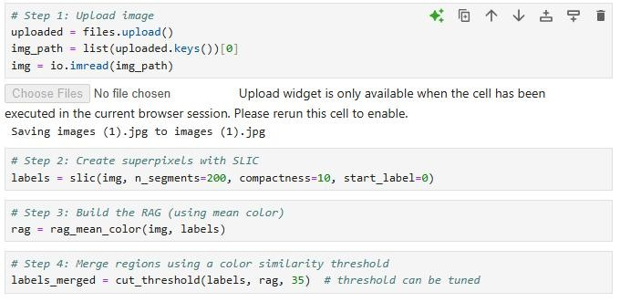
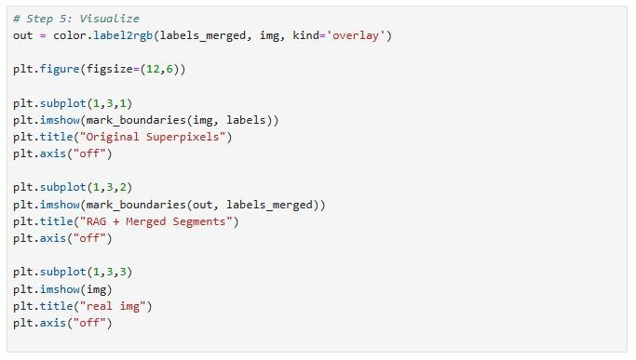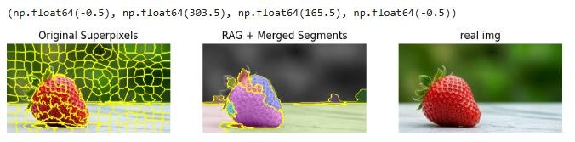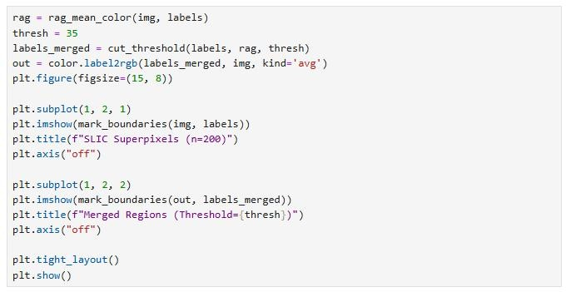
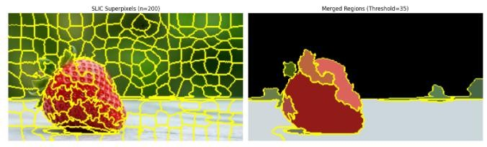
Task 2:
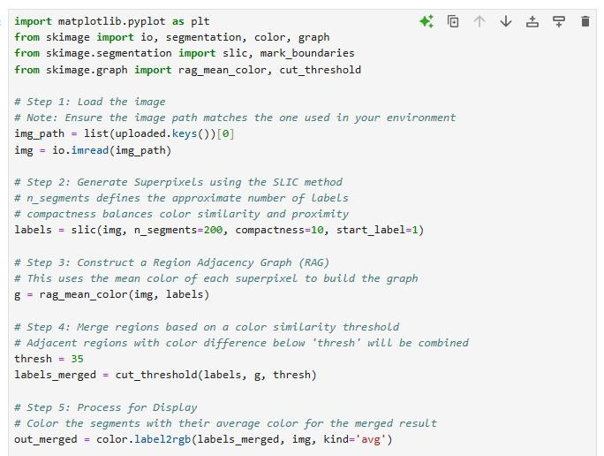
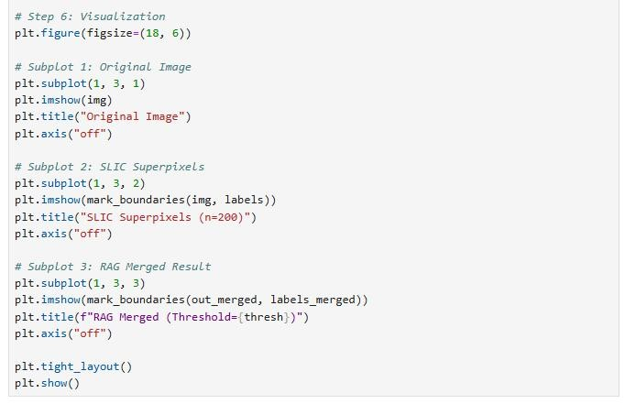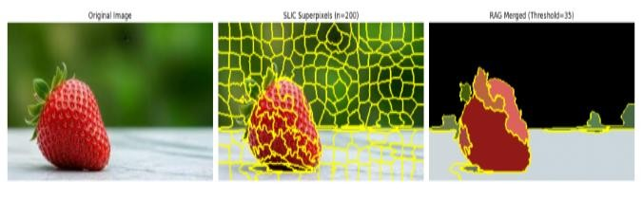
Task 3:
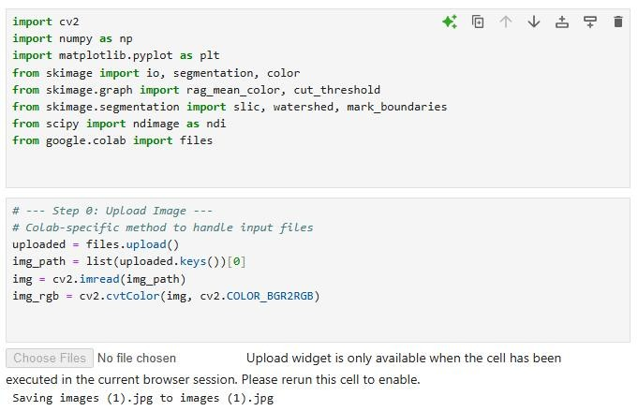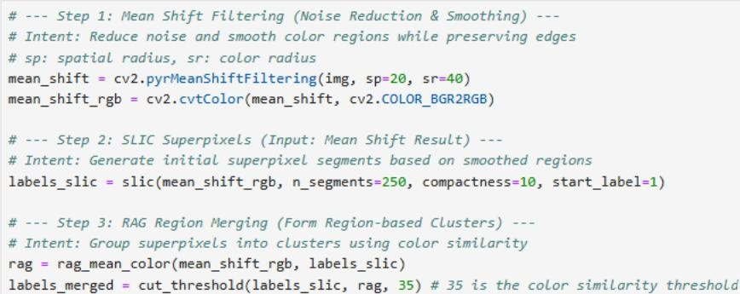
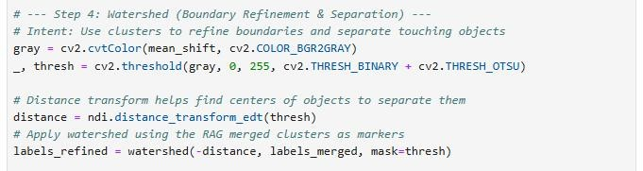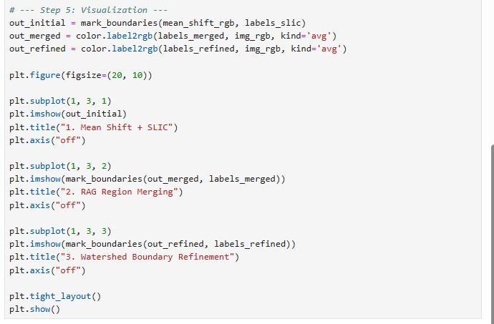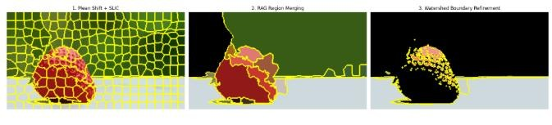

Lab 8: Felzenszwalb Graph-Based Segmentation
Lab 8 focuses on unsupervised image segmentation using Felzenszwalb’s graph-based algorithm. The main goal is to understand how the scale parameter affects the segmentation results.The process starts by loading and preparing the image, followed by applying a bilateral filter to reduce noise while preserving edges. The Felzenszwalb algorithm is then applied with different scale values (50, 100, 200, and 400).For each scale, the number and size of segments are calculated. Students observe that smaller scale values produce many small segments, while larger values result in fewer and larger regions.The results are displayed visually, allowing easy comparison of how segmentation changes with scale.Overall, this lab helps students understand how parameter tuning affects graph-based segmentation and prepares them for more advanced image analysis techniques.
Task 1:
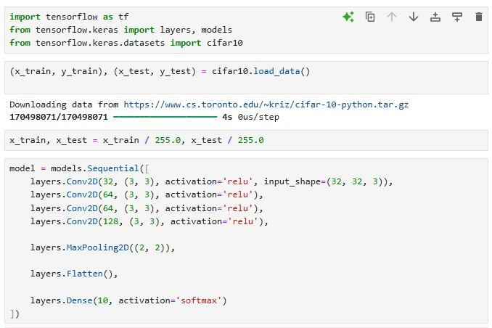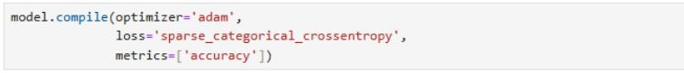
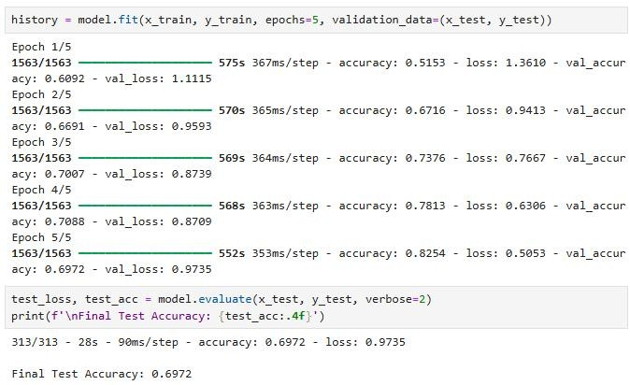
Task 2:
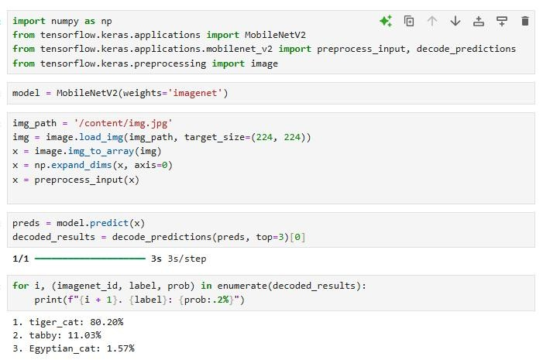

Lab 9: Image Segmentation Pipeline
Lab 9 presents an advanced image segmentation pipeline that combines multiple techniques for better object separation. The process starts by smoothing the input image using bilateral filtering, which reduces noise while preserving edges.Next, Felzenszwalb’s graph-based method is applied to divide the image into smaller regions (over-segmentation). These regions are then used as markers for the watershed algorithm. A gradient map is created using the Sobel operator, and watershed segmentation is applied to merge regions and refine object boundaries.The results are shown step by step, including the original image, smoothed image, segmented regions, and final output.Overall, this lab demonstrates how combining different segmentation techniques can improve accuracy and produce meaningful object boundaries, making it useful for real-world applications like
obj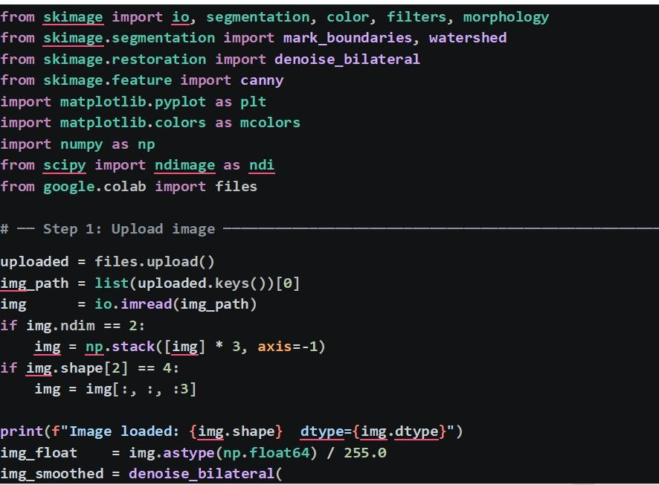e ct detection and image analysis.
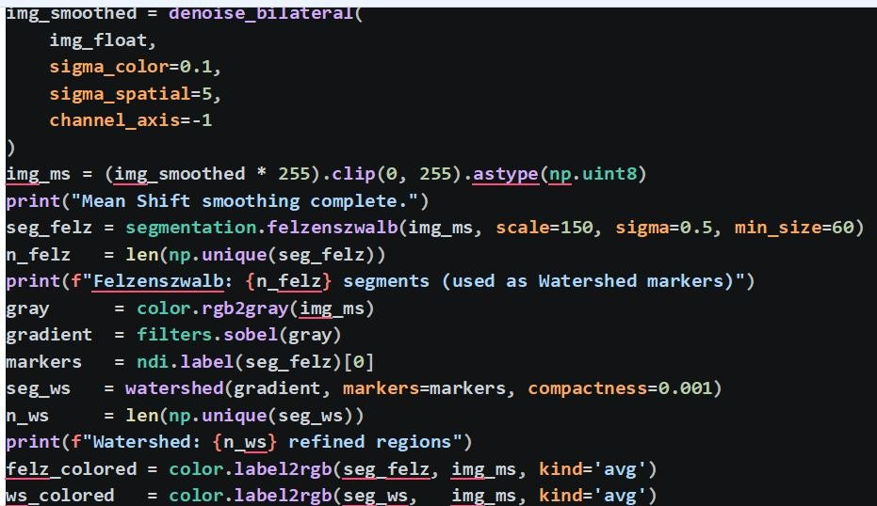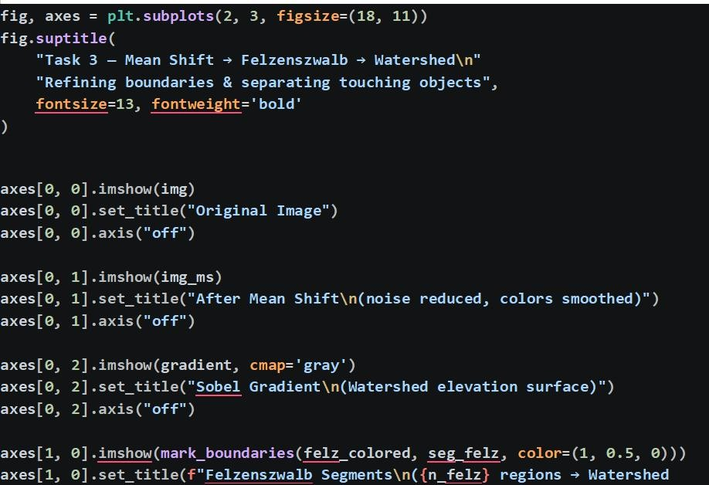
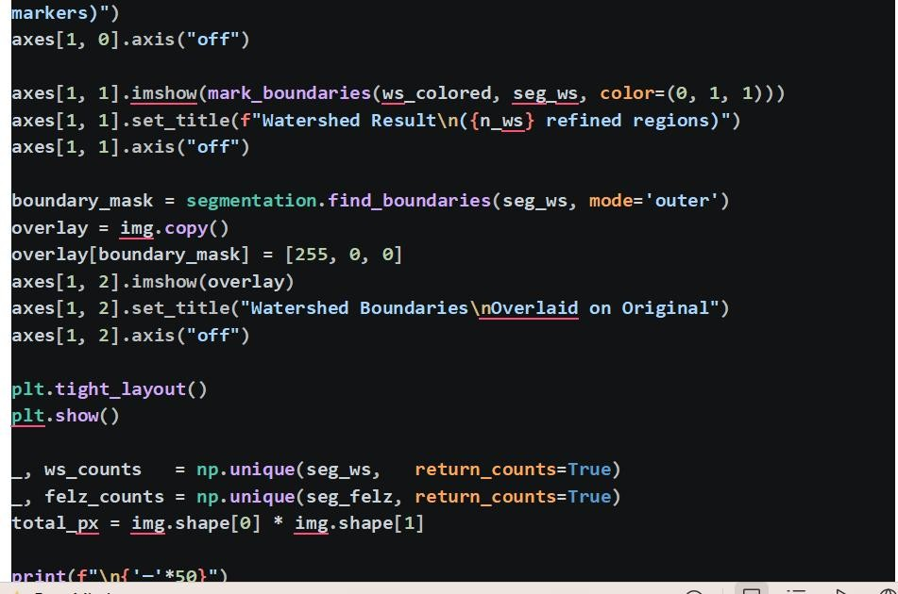
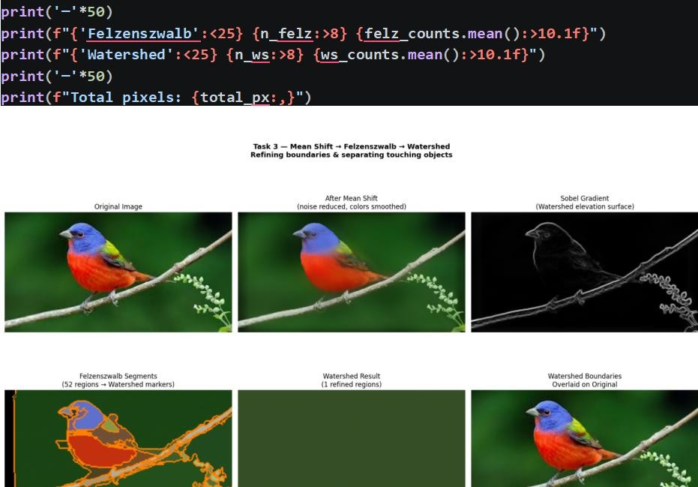

Lab 10: CIFAR-10 Image Classification using CNN
Lab 10 focuses on image classification using a Convolutional Neural Network (CNN) on the CIFAR-10 dataset, which contains 60,000 small color images from 10 different classes.The process begins by loading and normalizing the data. A CNN model is then built using multiple convolutional layers with ReLU activation, followed by max-pooling, flattening, and dense layers for classification.The model is trained for a few epochs using the Adam optimizer and cross-entropy loss. During training, accuracy improves significantly, but validation accuracy is lower, indicating slight overfitting.Overall, this lab demonstrates how CNNs can be used for multi-class image classification and highlights the importance of improving models using techniques like dropout or data augmentation
Load library
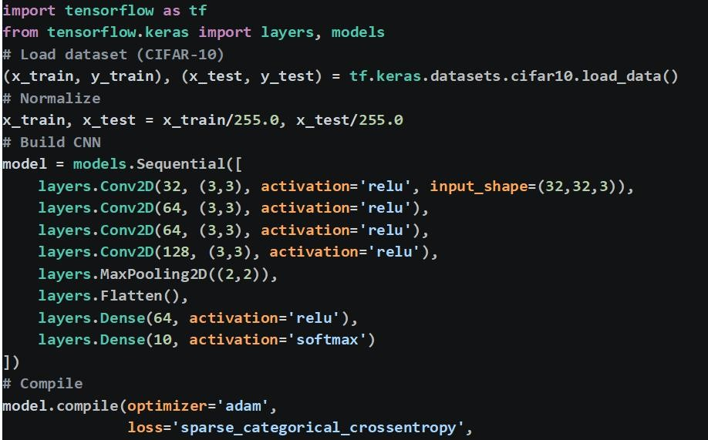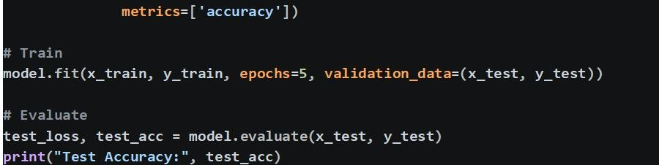
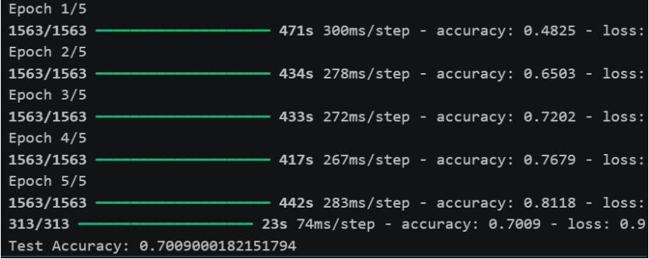

Lab 11: Image Classification using Pre-trained CNN (MobileNetV2)
Lab 11 demonstrates transfer learning for image classification using a pre-trained CNN called MobileNetV2, which is trained on the ImageNet dataset containing over 1.4 million images.The lab shows how to load images from local files or URLs, preprocess them by resizing to 224×224 and converting them into the required format, and then feed them into the pre-trained model for prediction.The model outputs probabilities for different classes, and the top predictions are displayed along with the input image. Tests are performed on various images such as animals, vehicles, and food items.Overall, this lab highlights the power of transfer learning, showing how a pre-trained model can accurately classify new images without additional training, making it highly practical for real-world applications.
Load library:
: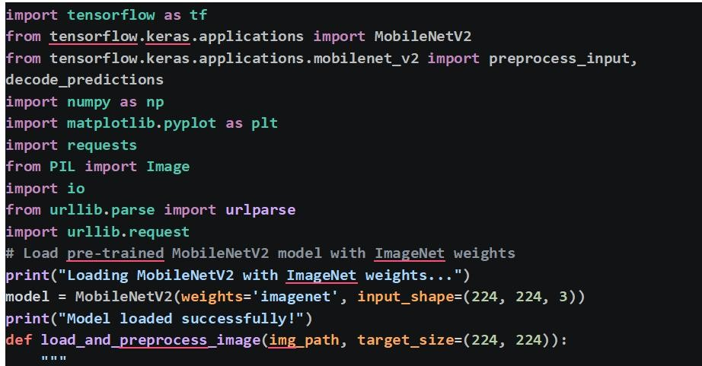
Load image:
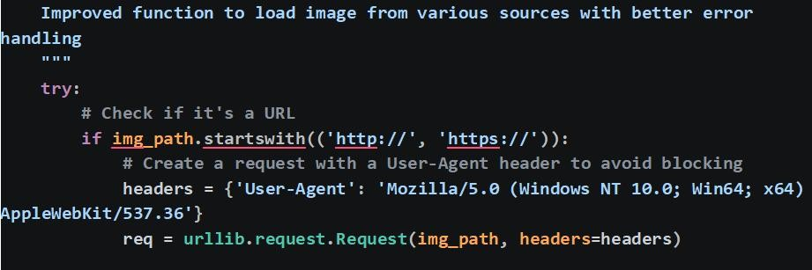
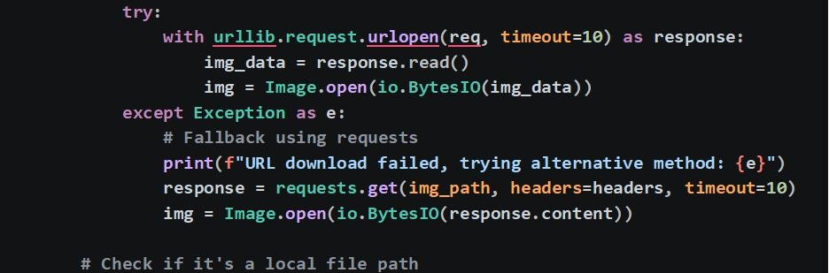
Convert to RGB:
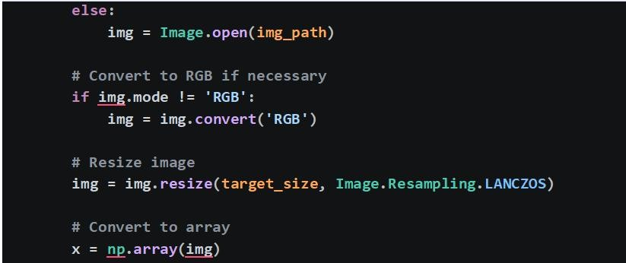
CONVERT TO ARRAY:
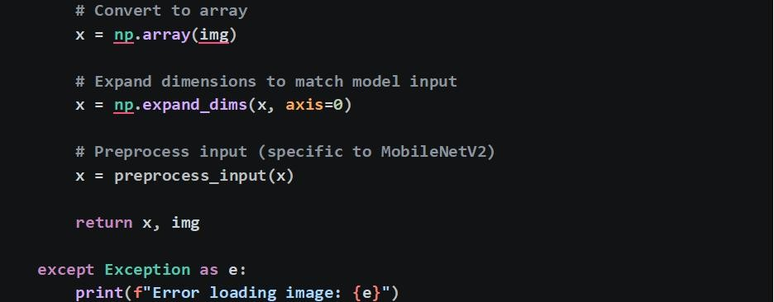
LOAD AND PREPROCESS IMAGE:
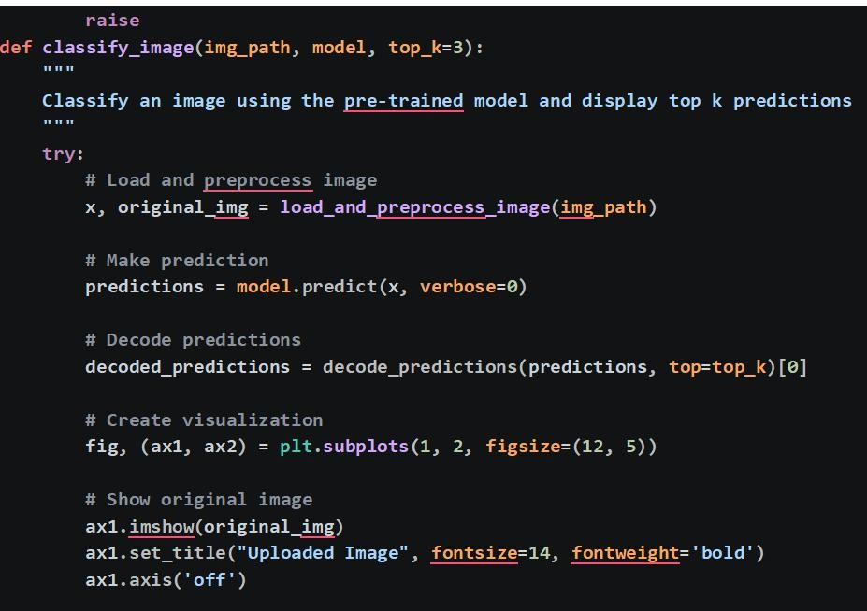
PREDICTION AS BAR CHART:
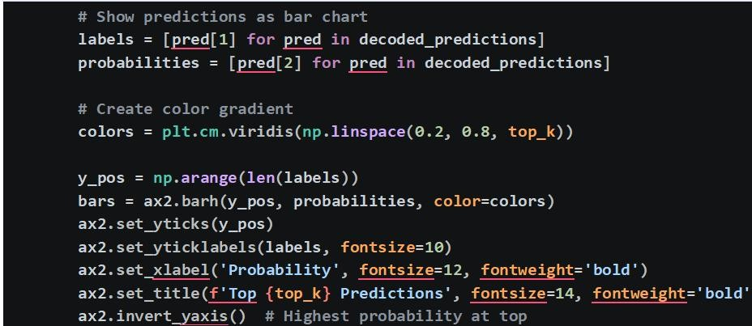
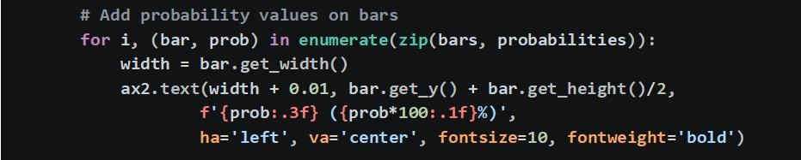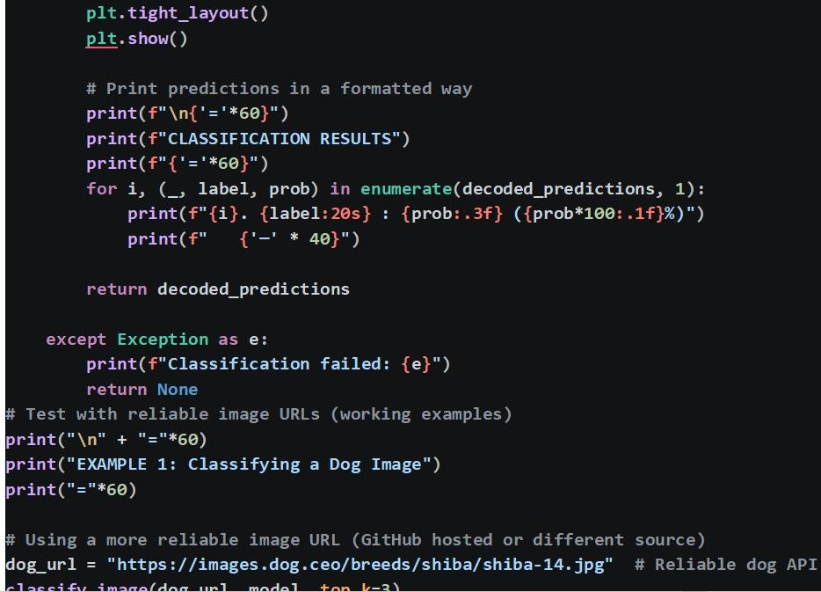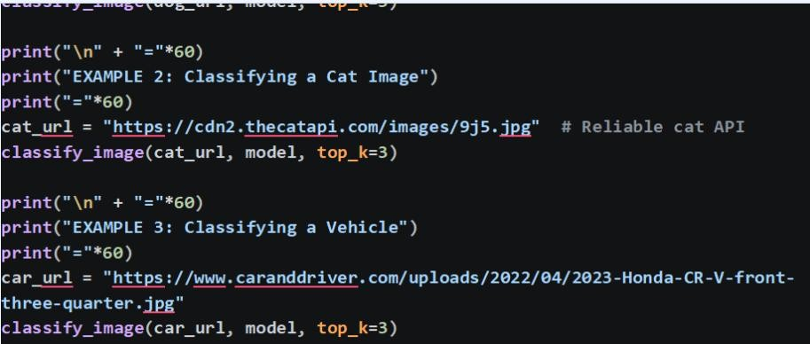
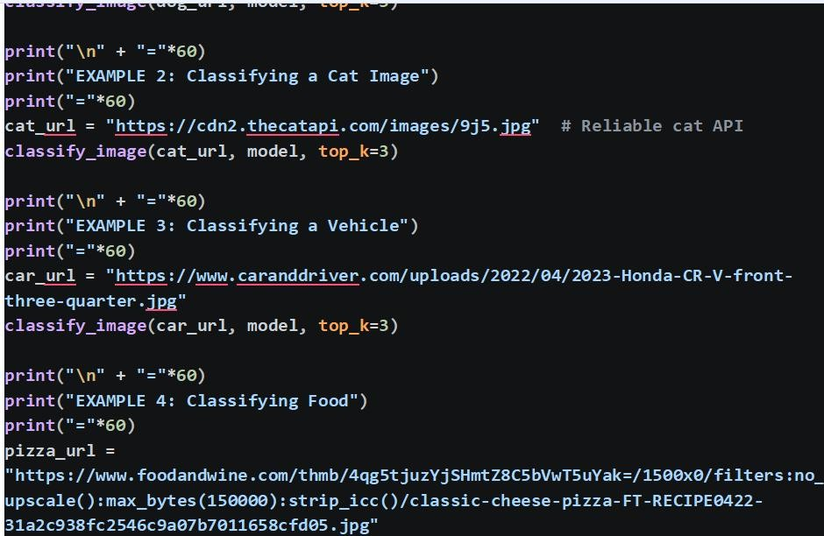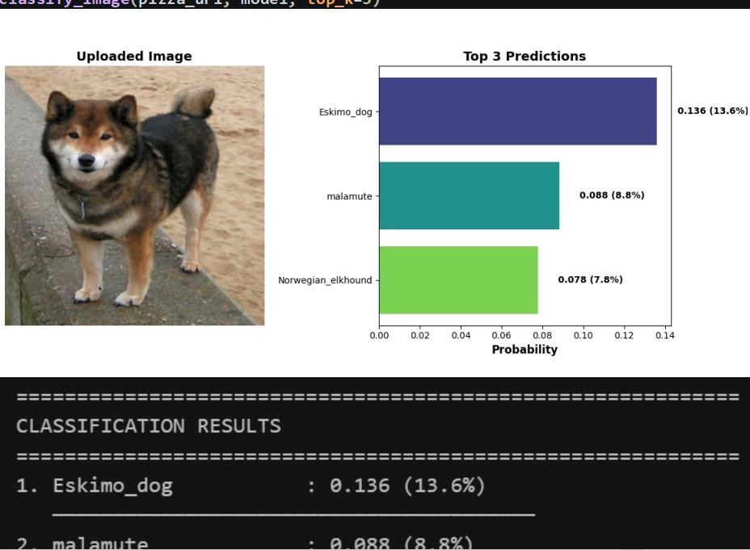
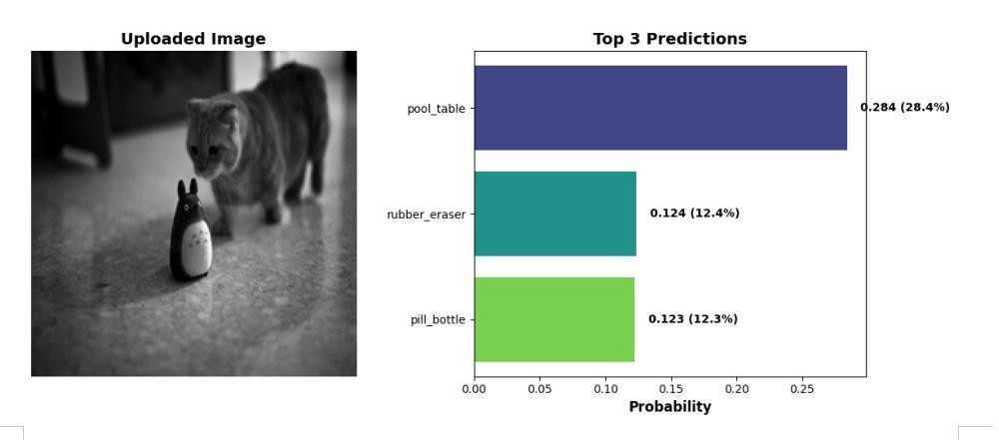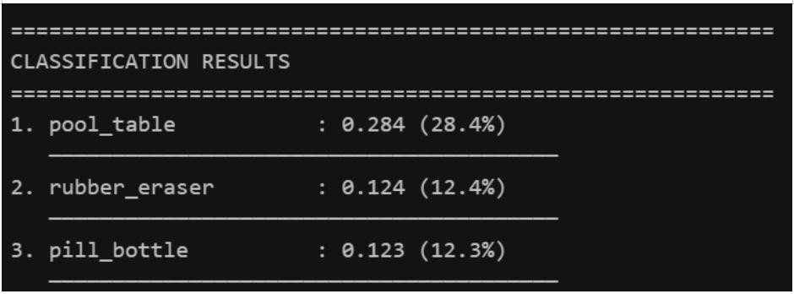

Lab 12: Simple Linear Regression with Scikit-Learn
This lab provides a concise and practical introduction to linear regression using the Scikit-Learn library. The workflow begins with importing the necessary modules: NumPy for numerical operations, Matplotlib for visualization, and the LinearRegression class from Scikit-Learn.A simple synthetic dataset is created, where study hours serve as the input feature (X) and corresponding exam marks as the target variable (y). The features are properly reshaped to meet the library's requirements, and the model is trained using the .fit() method. After training, the model is used to predict exam marks for a new input value (7 hours of study), and the result is printed.The lab then visualizes both the actual data points as a scatter plot and the fitted regression line on the same graph, providing a clear visual confirmation of the linear relationship. This notebook is ideal for beginners to understand the complete supervised learning workflow: preparing data, training a model, making predictions, and evaluating results visually.It highlights the simplicity and efficiency of Scikit-Learn for basic machine learning tasks and sets a strong foundation for exploring more complex regression problems and evaluation metrics.
LOAD
LIBRARY:
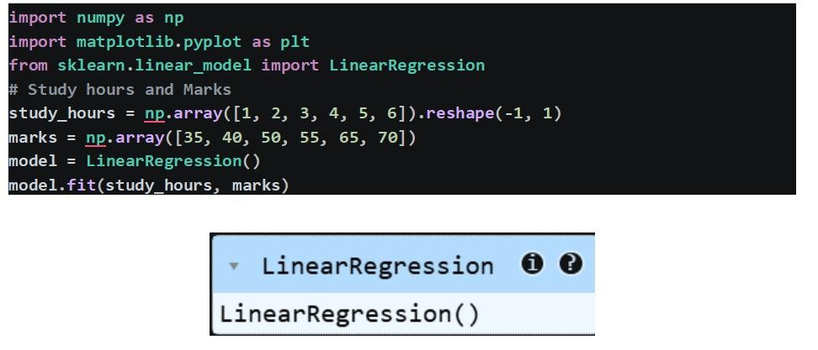
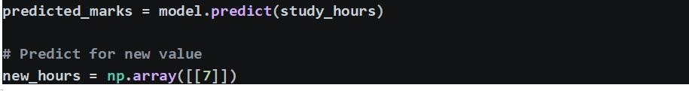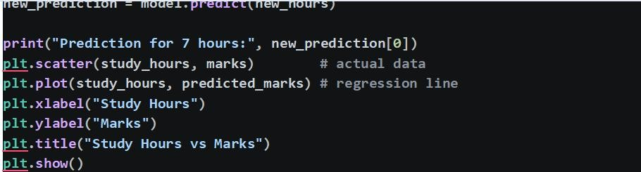

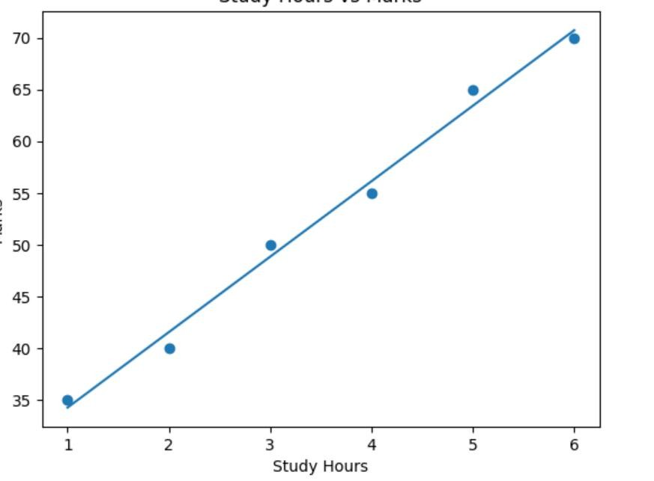

Lab 13: Feature Extraction Using SIFT in OpenCV
This notebook introduces the Scale-Invariant Feature Transform (SIFT) algorithm for keypoint detection and feature extraction using OpenCV. The lab begins by allowing users to upload images via Google Colab's built-in file upload widget. Each uploaded image is read using OpenCV, converted to grayscale, and passed to cv2.SIFT_create() to initialize the SIFT detector. Keypoints and their corresponding local feature descriptors are extracted for each image, and the shapes of the descriptor matrices are printed to demonstrate feature dimensionality. The keypoints are then drawn on the original images and displayed side-by-side using Matplotlib.SIFT is a powerful computer vision technique that identifies distinctive image features that remain invariant to scaling, rotation, translation, and partial illumination changes. This makes SIFT particularly valuable for applications such as image stitching, object recognition, 3D reconstruction, and structure from motion. The lab provides hands-on experience with one of the most robust and widely used feature extraction methods, illustrating how local image features can be detected and represented for downstream computer vision tasks.
LOAD
LIBRARY:
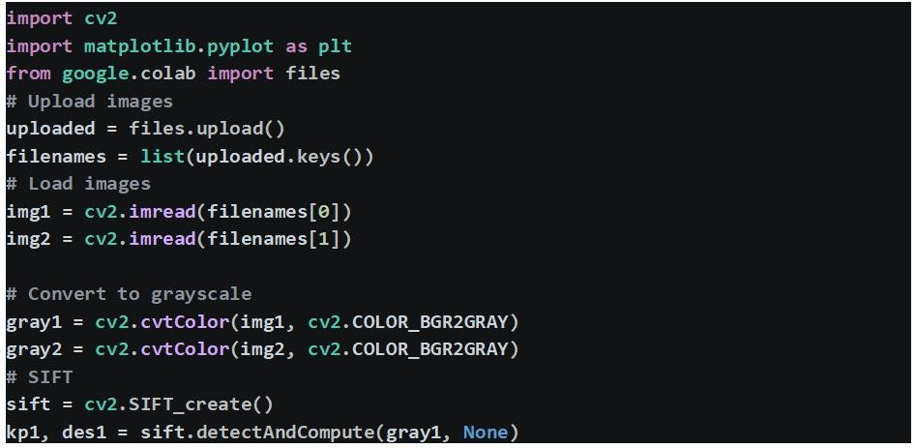
CONVERT BGR TO RGB
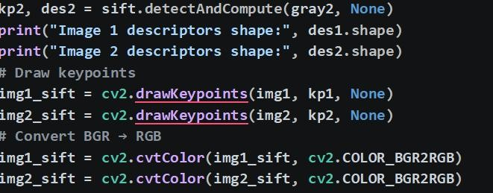
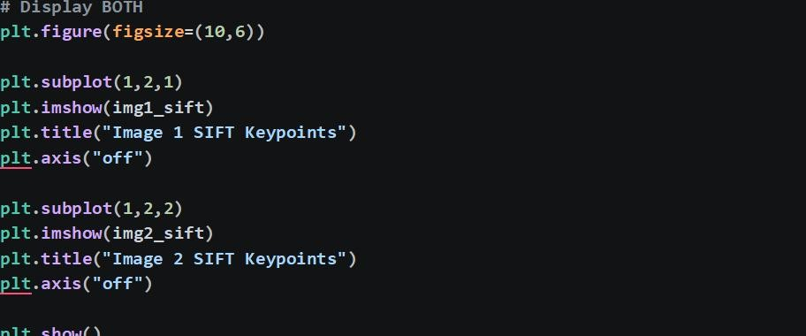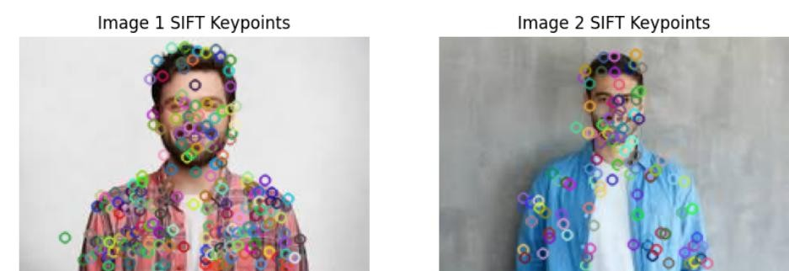

14: HOG Feature Extraction for Image Analysis
This lab demonstrates the use of Histogram of Oriented Gradients (HOG) for dense feature extraction in image analysis. After uploading an image using Google Colab's file interface, the image is read with OpenCV and converted to grayscale to simplify the gradient computation. The hog() function from skimage.feature is then applied, which divides the image into small spatial cells, computes gradient orientation histograms for each cell, and normalizes them across larger blocks to achieve illumination invariance. Key parameters such as orientations, pixels_per_cell, and cells_per_block are specified to control the granularity and dimensionality of the resulting feature vector. The total number of HOG features is printed, providing insight into the descriptor's size. The lab also visualizes the original grayscale image alongside a directional gradient image that represents the HOG features. HOG descriptors are widely used in object detection (e.g., pedestrian detection) and image classification tasks because they effectively capture edge and gradient structure while remaining invariant to small changes in illumination and contrast. This lab provides a practical introduction to a fundamental technique in handcrafted feature extraction.
LOAD LIBRARY
Y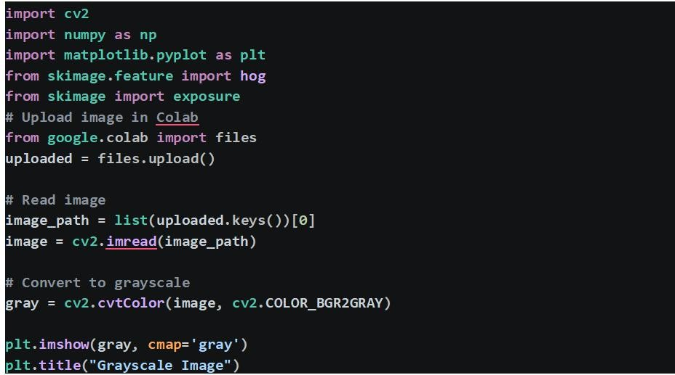
:
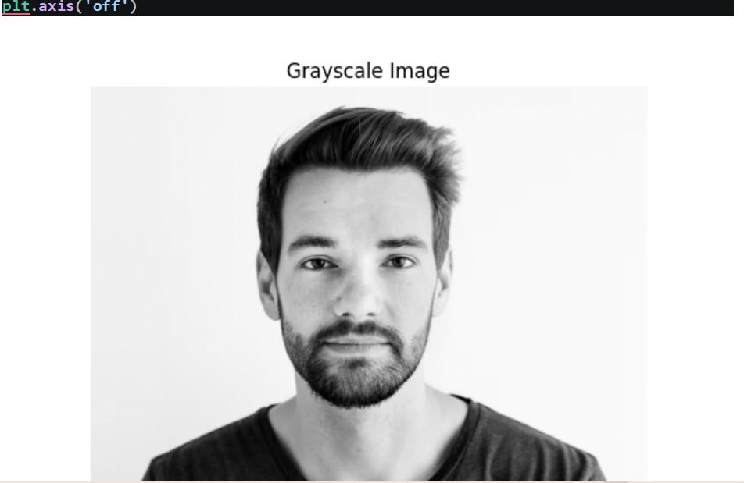
APPLY HOD:
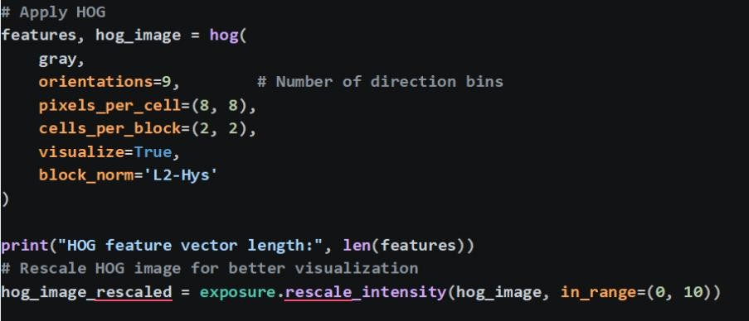

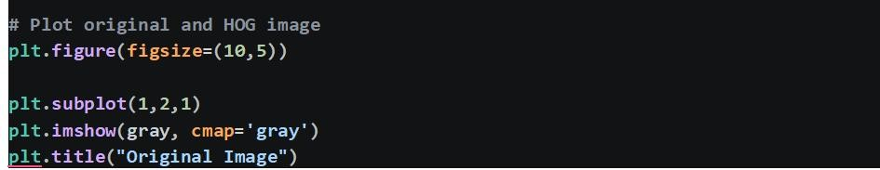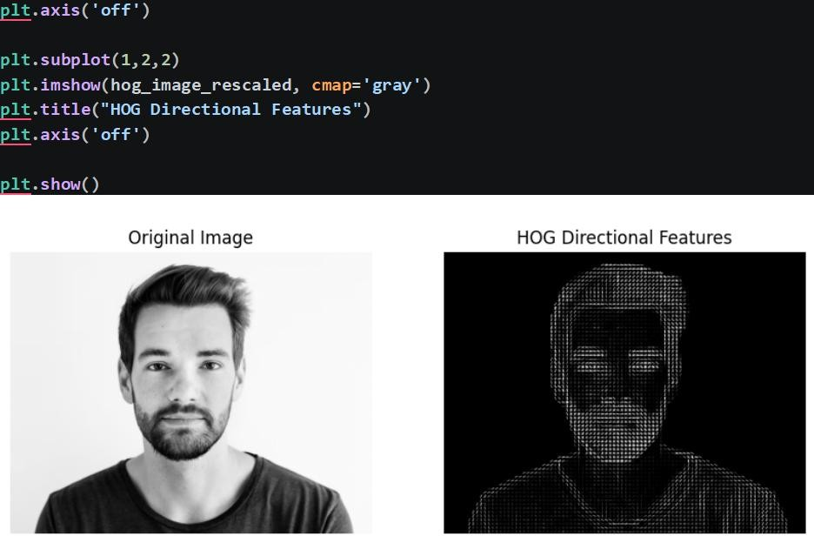
Conclusion
This lab manual provided a comprehensive, hands-on journey through the fundamental concepts, classical techniques, and advanced deep learning architectures that form the backbone of modern computer vision. Spanning fourteen exercises, the labs progressively built proficiency across the entire computer vision pipeline—from basic image manipulation and predictive modeling to sophisticated feature extraction, object detection, and neural network-based classification.
The initial labs established essential skills in image processing using OpenCV, including reading, writing, and transforming images, applying geometric transformations, and performing essential filtering and edge detection operations. These foundational tasks are critical for any subsequent vision application, as they enable effective preprocessing and noise reduction.
Subsequent exercises introduced core feature extraction techniques. Labs on SIFT (Scale-Invariant Feature Transform) and HOG (Histogram of Oriented Gradients) demonstrated how to detect and describe local image features that remain invariant to scale, rotation, and illumination changes—key requirements for robust object recognition and image matching tasks. Feature matching and homography estimation were also explored, providing practical experience with image stitching and panorama creation.

